Technical rider Asrai 2017
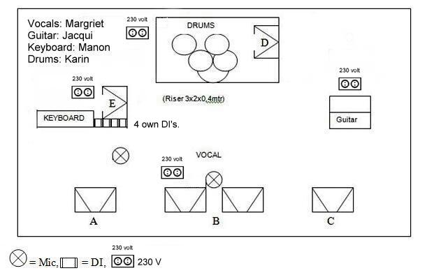

FOH requirements:
System: A full range system of an A-brand quality (Enough power to have a SPL of 110 dBa without distortion at FOH position, lots of sublow. Crossovers/Processor adjustable if needed
Desk: Midas, Yamaha, A&H, Soundcraft. No digital please.. Desk should
be placed at 2/3 size of venue distance to stage. Not upon or under balcony, not against back wall
min. 32 channels
min. 8 subgroup or vca
4x parametric eq
3 fx send per channel
6 more aux sends if there is no separate monitormixer
FX rack: 1x stereo 1/3 oct. graphic eq
8x noise gate
4x compressor
2x reverb unit
1x delay unit with tap
1x cd player
Misc:
-Intercom FOH – monitor
-Talkback FOH – stage
-1x riser (Drums: 3x2x0,4mtr)

FOH Channellist

CH | INSTRUMENT | MIC | INSERT
1 | Kick | BETA 91 | Gate 1
2 | Kick | BETA 52 | Gate 2
3 | Snare (top) | SM 57 | Gate 3
4 | Snare (bottom) | SM 57 | Gate 4
5 | Hi Hat | KM184 / BETA98
6 | Racktom 1 | E604 / BETA 56 | Gate 5
7 | Racktom 2 | E604 / BETA 56 | Gate 6
8 | Floortom | E604 / BETA 56 | Gate 7
9 | Overhead left | KM184 / BETA98
10 | Overhead right | KM184 / BETA98
11 | Guitar left | DI
12 | Guitar right | DI
13 | Keyboard | Own DI
14 | Harddisk 5 Tracks L | Jack/ own DI
15 | Harddisk 6 Tracks R | Jack/ own DI
16 | Harddisk Bass | Jack/ own DI
17 | Vocal Lead | Own Mic (cond.) Phantom) | Compressor 3
18 | Vocal Keys | SM 58 | Compressor 4
19 | Reverb 1 left | M2000, SPX990,
20 | Reverb 1 right | REV-5, LXP-15,
21 | Reverb 2 left
22 | Reverb 2 right
23 | Delay left | D-two, TC 2290
24 | Delay right

*Note: All equipment should be of A-brand quality, in good maintained working
condition. And that means everything.

Technical specs are part of the contract, if requirements can’t be met, inform us in advance.

BACKDROP: Length: 3 meters height: 2 meters

Band members: ASRAI
Vocals - Margriet, Guitar – Jacqui, Keys – Manon, Drums - Karin

MONITOR requirements:
System: Min. 6 groups monitorsystem (A, B, C, D, E, F)
On all monitor groups 1/3 oct eq

Monitor Channellist

CH | INSTRUMENT | Vocals  Margriet | Keys  Manon | Guitar  Jacqui | Drums  Karin | In Ear Lead Vox
1 | Kick (sm91) | x | x | x | X | x
2 | Kick
3 | Snare (top) | x | x | x | x | x
4 | Snare (bottom)
5 | Hi Hat | x | x | x | x | x
6 | Racktom 1 |  |  |  | x
7 | Racktom 2 |  |  |  | x
8 | Floortom |  |  |  | x
9 | Overhead left
10 | Overhead right
11 | Guitar L | x | x | x | x | x
12 | Guitar R
13 | Keyboard | x | X | x | x | x
14 | Harddisk Tracks L (HD ch5) | X | X | x | x | x
15 | Harddisk Tracks R (HD ch6) | X | X | x | x | x
16 | Vocal Lead | X | X | x | X | x
17 | Vocal Keys | x | X |  |  | X

x = normal sound level
X = accentuated sound level

*Note : Careful with the In-Ear send!

Band members: ASRAI
Vocals - Margriet, Guitar – Jacqui, Keys – Manon, Drums - Karin

